**Raj Singh: COSC 4353 Software Design**

**Group 10 - Assignment 3**

**GROUP 10: Satya Sai Sribhashyam, Tasneem Patel, Jenish Bhadola**

1. **Provide link to GitHub repository for TAs to view the code. Code should include unit tests.(5 points)**

<https://github.com/Jnbhadol/Project_Group10>

1. **List what backend technologies you are using and why? (2 points)**

For the backend, we have used the Flask framework of Python to orient small deployments instead of large deployments. Using the flask framework and small deployment gave us the flexibility to handle any requests and freely use the database. Using the flask framework was convenient because it requires minimal library importing, while at the same time it was also simple in usage and syntax rules.

**Coverage Report:**

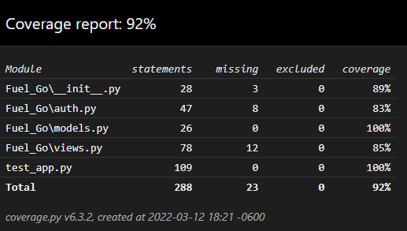

1. **IMPORTANT: list who did what within the group. TAs should be able to validate in GitHub, otherwise team members who didn't contribute will receive a ZERO.**

**Fill in this table, provide as much details possible:**

| **Group Member Name** | **What is your contribution?** | **Discussion Notes** |
| --- | --- | --- |
| **Tasneem Patel** | Backend Coding | Did the backend coding for login registration, profile, and fuel quote pages and helped a little in unit testing. |
| **Satya Sai Sribhashyam** | Debugging, edited CSS file, updated HTMl pages | Fixed hover buttons in CSS file, and updated all the front end pages so that backend receives data from front-end and we can access data through requests. |
| **Jenish Bhadola** | Unit testing and code coverage | Did the unit testing and code coverage part and fixed some issues in the backend coding |